Parkway Academy Handwriting Policy

Head of School  B Paull | Sign and Date | 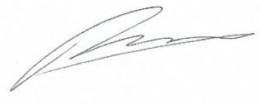  09.11.25

Next Review Date | 09.11.26
Committee Responsible | Governing Board – approved: 11.11.24
 | Governing Board – approved:

Change History

Version | Date | Change Description | Stored
1 | 09.11.25 | Removal of L. Hothersall as Executive Principal | HJS Website
2 | 05.09.26 | Rebranding from Howard Junior School to Parkway Academy | OneDrive – PWA Policies
3
4
5
6

Handwriting Policy
At Parkway Academy we use Letter-join’s on-line handwriting resource and Lesson Planners as the basis of our handwriting policy as it covers all the requirements of the National Curriculum.
Objective
Handwriting is a basic skill that influences the quality of work throughout the curriculum. By the end of Key Stage 2 all pupils should have the ability to produce fluent, legible and, eventually, speedy joined-up handwriting, and to understand the different forms of handwriting used for different purposes.
Our intention is to make handwriting an automatic process that does not interfere with creative and mental thinking.
Aims:

- To develop a neat, legible, speedy handwriting style using continuous cursive letters, which leads to producing letters and words automatically in independent writing.
- To establish and maintain high expectations for the presentation of written work.
- For pupils to understand, by the end of Year 6, the importance of neat presentation and the need for different letterforms (cursive, printed or capital letters) to help communicate meaning clearly.
Expectations
All teaching staff are expected to model the cursive style of handwriting chosen for each year group in our school in all their handwriting, whether on whiteboards, displays or in pupils’ books.
Consistency throughout the school
Pupils should experience coherence and continuity in the learning and teaching of handwriting across all school years and be encouraged to take pride in the presentation of their work. Our objective is to help pupils enjoy learning and developing their handwriting with a sense of achievement and pride.
Handwriting frequency
Handwriting is a cross-curricular task and will be taken into consideration during all lessons. Formal teaching of handwriting will be carried out three times per week to ensure Key Stage targets are met.
Pens and pencils
Children will start handwriting using a soft pencil. When fine motor skills have been established and pupils have met the success criteria below, a pen licence will be awarded:
- All letters start and finish on the line
- Lead in lines and lead out lines are used consistently
- All letters are joined correctly, as per the images on page 3
- All letters are formed correctly as per the images on pages 4 and 5

Diagonal joins
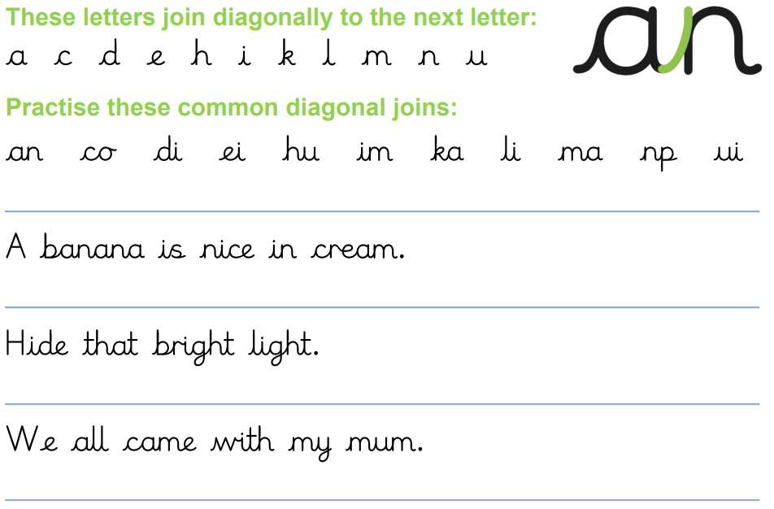
Horizontal joins
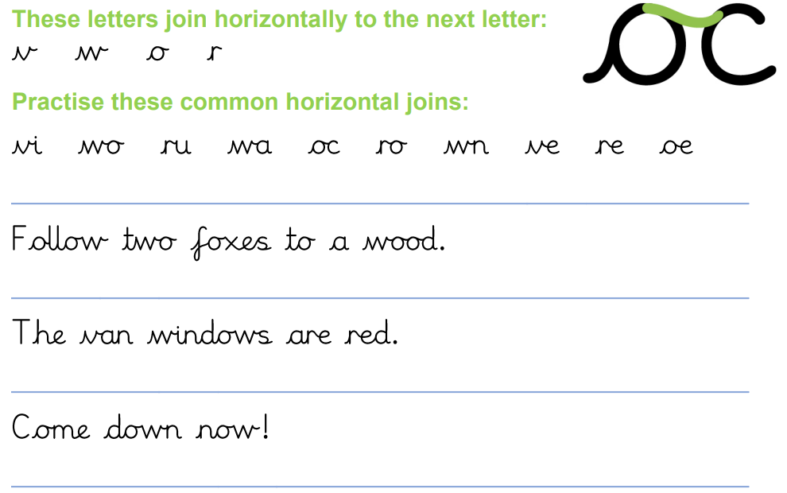

Cursive Lower Case Letter Formations
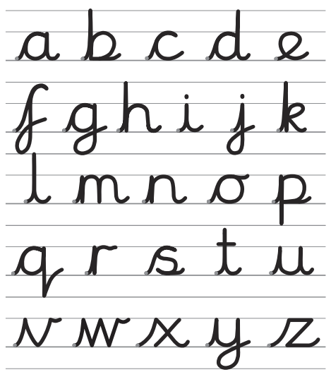

Capital Letter Formations
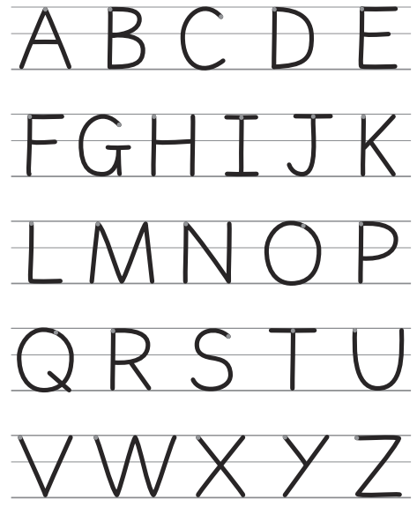

Inclusion
For children who experience handwriting difficulties due to fine motor development, including those who are left-handed and those with special educational needs, the appropriate additional support will be put into place. Letter-join’s Lesson Planners all include adaption activities for extra practise/challenge.
Handwriting at Home
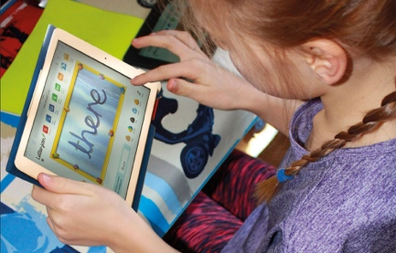
Pupils are encouraged to practise their handwriting at home by using the Pupil log-in for Letter-join. Teachers can set Home Learning Tasks which may include:
- Magic Patterns
- Magic Words
- SoundMatch
- PhonicsMatch
- LetterMatch
- LetterLotto
- Letter Families activity
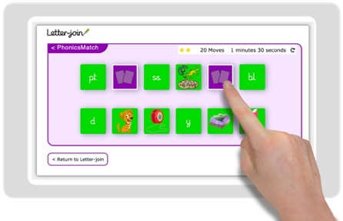
- Word Search
- Word Bank
- Spelling lists
- Write it Right!
Children can also watch the word and letter animations and practise and explore other handwriting resources on Letter-join.

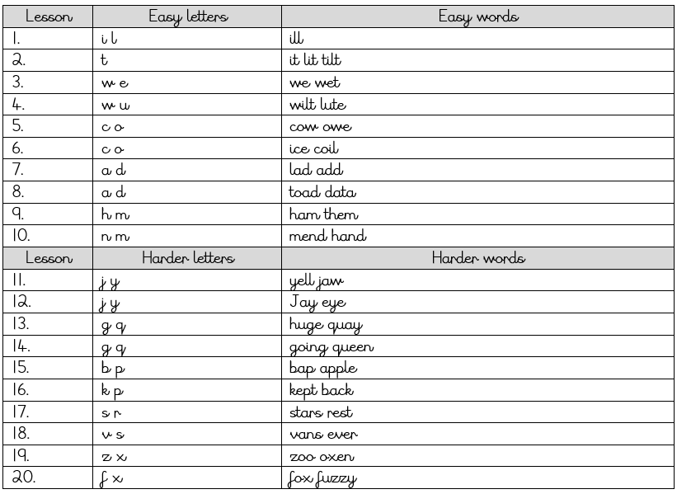
Handwriting Catch Up Teaching Sequence
The following teaching sequence can be used to introduce all the correct letter formations and to prepare pupils for the year group lesson planner modules that follow.

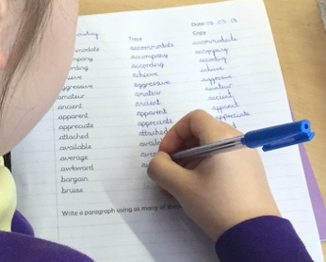
Lower Key Stage 2: Years 3 and 4
Formal handwriting lessons will take place three times a week in Lower Key Stage 2.
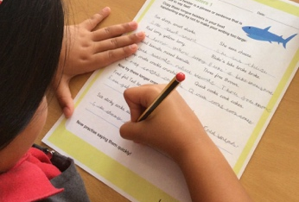
Lesson Planner Module 4 for Year 3 is targeted at children in lower KS2 where pupils should be using a cursive style throughout their independent writing in all subjects, helping to refine their handwriting in line with the requirements of each lesson. This module covers topics such as dictation, double letters, number vocabulary, palindromes, tongue twisters, MFL (Spanish), onomatopoeia, simile and statutory spellings.
Completion of Module 4 should ensure improvement in the legibility, consistency and quality of the children’s handwriting through a variety of resources which link handwriting to other areas of the curriculum.
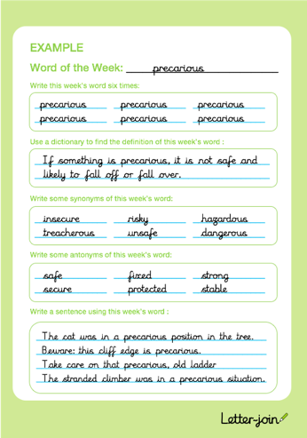
Lesson Planner Module 5 for Year 4 focuses on using handwriting practice to support other subjects in the curriculum and, at the same time, builds on fluency and consistency. This module aims to promote meaningful links with other subjects such as English, maths, science, geography and Spanish. Making such links enables children to apply the skills they are learning in context and also provides depth to the curriculum.
Learners will continue to build on producing fluent, consistent and legible handwriting through the regular practise offered in this module’s lessons.
On concluding this module, children will have practised applying size-appropriate handwriting to all areas of the curriculum whilst maintaining fluency and legibility.

Upper Key Stage 2: Years 5 and 6
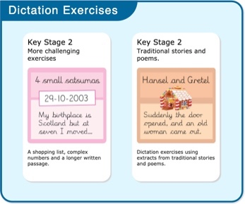
More advanced handwriting techniques will be taught during three weekly lessons:
- reinforcing cursive handwriting across the curriculum
- form-filling/labelling using printed and capital letters
- dictation exercises promoting quick note-taking and speedy handwriting writing skills
- KS2 SATs SPaG practise
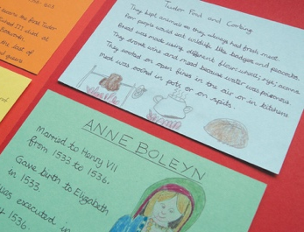
Lesson Planner Module 6 for Year 5 continues to build on combining fluent handwriting with other subjects across the curriculum.
In this module, learners will have plenty of opportunity to develop the stamina and skills to write at length, with accurate spelling and punctuation. With Letter-join’s wide range of resources they will be able to work towards producing consistently neat and well-presented handwriting in all curriculum subjects.
On completing this module, children should be producing cursive writing automatically, enabling them to focus on the content of their work rather than the process of writing.
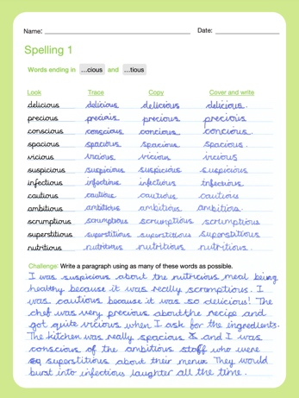
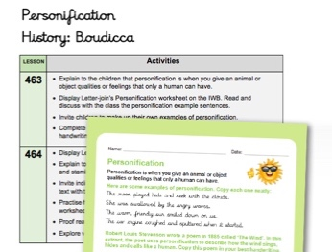
Lesson Planner Module 7 Year 6 presents learners with a range of tasks where they have to decide on an appropriate style of handwriting. Promoting speedy, fluent writing continues to be a strong feature. Challenging dictation exercises will refine pupils’ revising and checking skills as well as boosting their handwriting speed, stamina and fluency. A range of curriculum-based worksheets will give pupils the opportunity to practise writing at length.
Module 7 also contains a series of worksheets to aid KS2 SATs SPaG revision. They are designed to support year 6 pupils in meeting expected standards for spelling, punctuation and grammar, with lots of SPaG preparation and plenty of handwriting practice.
By the end of this module, children should be able to adapt their handwriting for a range of tasks and purposes and to create different effects. They should be clear about what standard of handwriting is appropriate for a particular task.

Correct posture and pencil grip for handwriting
Pupils should be taught to sit correctly at a table, holding a pencil comfortably and correctly.
Sitting position
Sit with a straight back, not leaning over the page
Pull the chair close in to the table
Keep feet flat on the floor
Sit right back in the seat

The table reaches to below elbow height

Paper position for right-handed children.

Left-handed children
Left-handed children may find it difficult to follow the movements of right-handed teachers as they model letter formation (and vice versa). Teachers should demonstrate to left-handers on an individual or group basis.
- Left-handed pupils should sit to the left of a right-handed child so that they are not competing for space.
- Pupils should position the paper/book to their left side and slanted, as shown.
- Pencils should not be held too close to the point as this can interrupt pupils’ line of
vision.
- Extra practice with left-to-right exercises may be necessary before pupils write
left-to-right automatically
Paper position for left-handed children.

The Tripod Pencil Grip
Both right and left handed children should be encouraged to use the tripod grip which allows the pen/pencil to be held securely whilst allowing controlled movements of the pen/pencil nib. We use the Tripod Grip Rhyme:
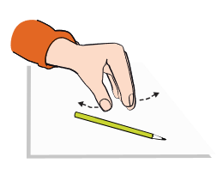
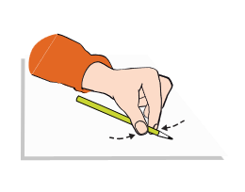
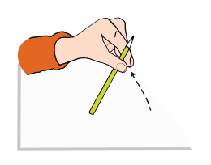
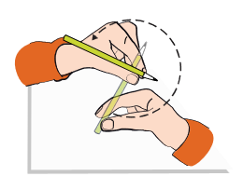
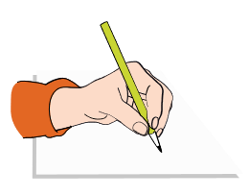
Point away the pencil, Pinch it near the tip, Lift if off the table, Spin it round... and grip.
Point away the pencil, Pinch it near the tip, Lift if off the table, Spin it round... and grip.
Right-handed pencil grip
Left-handed pencil grip

