Parkway Academy Working Wall Policy

Principal  B Paull | Sign and Date | 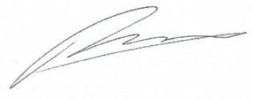  10.11.25

Next Review Date | 10.11.26
Committee Responsible | Academy Committee – approved:

Change History

Version | Date | Change Description | Stored
1 | 14.11.25 | Colour vision deficiency note added (page 3) | HJS School Website
2 | 05.09.26 | Rebranding from Parkway Academy to Parkway Academy | OneDrive – PWA Policies
3
4
5
6

Working Wall Policy

Research suggests…
‘Considerable amounts of wall displays appear cluttered and disorganised, making it more difficult for students to recognise and find pertinent information.’ (Apps & MacDonald, 2012).

‘Young children with immature regulation of focused attention are often placed in school classrooms containing many displays that are not relevant to ongoing instruction.’ (Fisher et al, 2014).

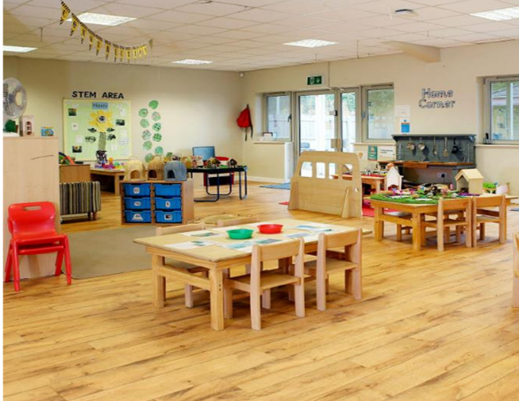
The same study also found that, ‘Children were more distracted by the visual environment, spent more time off task, and demonstrated smaller learning gains when the walls were highly decorated than when the decorations were removed.’ (Fisher et al, 2014).
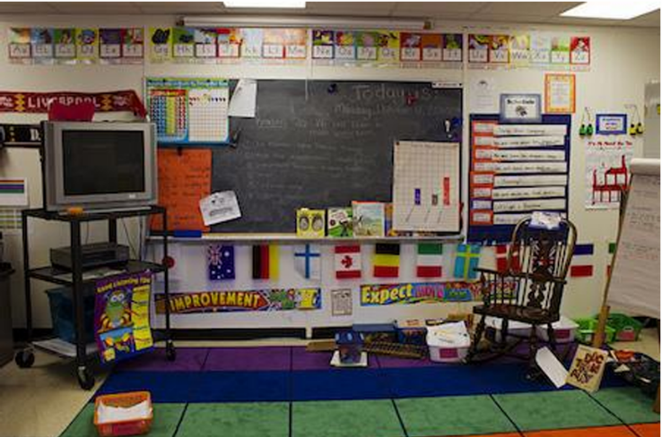
Aim of the Working Wall
To provide a specific selection of displayed curriculum content pertinent to the lesson(s) which teachers and pupils use to scaffold, reinforce and consolidate learning. Achieved through:

1. Using the working wall as a teaching tool that reinforces the points you are making
2. Updating regularly; adding to throughout a unit of work
3. Showing clear expectations (3 before me) that support learning

Principles of the working wall
1. Contrast – Use different colours to draw attention to the most important pieces of information. Lack of contrast blends everything together and is hard to read. Letters will be added next to the colour used to support pupils with colour vision deficiency. For example, R for red and B for blue. A star will also be added next to key vocabulary that adults wish for pupils to include within their independent work.

2. Alignment – Controls the readers eyes. You control how the pupils read the information by the layout you chose. Consider: What do you want to be read first? Left to right, columns or diagonally?

3. Proximately – The importance of keeping similar elements together. Keep key vocabulary in the same areas and knowledge organisers in the same areas.

4. Repetition – Brings consistency to the visual environment:
- Subject label
- Unit of work
- Key vocabulary
- Knowledge organiser
- Use of colour
- Use of drawings/diagrams/pictures
- Sequence of learning
  - 6 lessons (foundation subjects)
  - 4 lessons (maths) with adapted LO’s
  - Narrative map (English) & progressive class story, with success criteria during independent write
  - PE working walls to include LO’s
Interaction with the working wall
- Used throughout the lesson to add key information
- Referred to throughout the lesson to remind pupils of key facts
- Recap key learning points from the lesson/sequence of learning through retrieval practice

