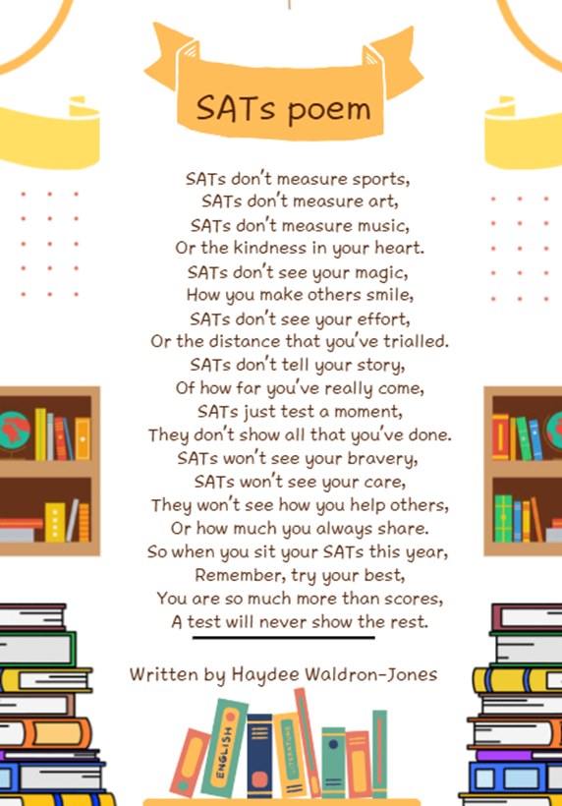

Finally, I would like to wish all our Year 6 pupils the best of luck for their upcoming SATs next week. I know your teachers have every confidence in you and we look forward to celebrating your achievements.
Please visit our class blogs to see what your child/children have been learning. You can find the blogs on our school website (www.howardjunior.co.uk) by clicking on: our school, staff and classes, and then selecting the required class.
Year 6 SAT’s
As we move closer to the upcoming Key Stage 2 SAT’s, we would like to remind parents and carers of our Year 6 children to please refer to our earlier letter regarding the free breakfast on offer for the year 6 children.
We would like to take the opportunity to say how immensely proud we all are of our Year 6 pupils and the dedicated staff who work alongside them. The effort, resilience and determination shown throughout this year has been incredible. It certainly hasn’t always been easy, but the perseverance and commitment demonstrated by everyone has been truly admirable.

hich are helping to
celebrate the hard work our pupils and staff have put in over this
academic year. Many of these have been made possible with the
hardwork of our wonderful PTFA who have put in countless hours to
enable us to give our pupils these wonderful experiences.
During this final half term our PTFA have some lovely events planned to cap
off a very successful year. Many of these are now in the diary and can be found
on the back of this newsletter. We thank our parents and carers for their
support so far this year and hope we can continue to receive this in the future.

Message from the Principal
To create predictable and consistent environments that are safe, we have
established a set of rules that are understood by all staff and our pupils.
Clear rules help young people feel emotionally safe. This is known as relational
practice and these rules form part of our everyday language to help build an
emotionally safe culture. We address the behaviours we see within these rules
and make it part of our everyday practice:
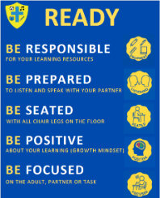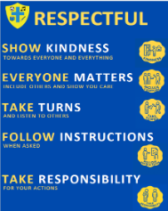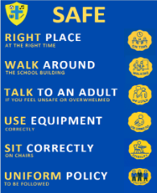


Mr. Ben Paull

Upcoming Dates
for your
diary
Howard Transition Day
29th June 2026
Year 6 End of SAT’s visit
15th May 2026
PTFA Bingo Night
26th June 2026
SAT’s Week
11th – 14th May

Warm Weather & Summer Term
A reminder that now we are in the summer term and we’re hoping to make the most of the nice weather, with lunches outside and plenty of playtime too! We would like to remind parents to ensure you send your children in with a sun hat and make sure sun cream is applied before school to keep them safe.
Please can parents also send in a named drink bottle with their child allowing us to keep them hydrated in this warm weather. Children are permitted to bring in water, squash or flavoured water (non-carbonated) in their bottle but please do NOT allow children to bring in fizzy drinks or fruit juices, these will not be permitted to be drunk during the school day.
We’re looking forward to all enjoying the nice weather together safely.

Attendance
A reminder of attendance – Our weekly attendance - any class collectively, who have reached 98% attendance over a week will enjoy a free non uniform day. The winners will be announced in the assembly on the Monday of each week and the non-uniform day, will be held on the Friday of that same week.
Individual prizes are awarded to each pupil who achieves 100% attendance for the whole term, or a whole year. Prizes are awarded in the respective end of term/year assemblies.

Upcoming Events

May
11th – 14th May | Year 6 SAT’s Week
15th May | Year 6 Visit to Gravity/McDonalds
20th May | Springwood Visit to Yr 6 Pupils
 | June
2nd June | Kings Lynn Academy Visit to Yr 6 pupils (parents after school)
5th June | PTFA - Movie Night – Zootropolis 2
9th June | Young Carers Activity Day – Lynnsport
11th June | King Edward VII- Visit to Yr 6 Pupils
16th June | Dance Festival
17th June | PTFA -World Cup Non uniform
19th June | PTFA – Non uniform – Rainbow colour
26th June | Young Carers Visit to Twinlakes
26th June | PTFA – Summer Bingo
29th June | Howard/KOA Transition Day
29th June | Meeting for New year 3 Parents 2.30pm
29th June- 1st July | King Edward VII & Kings Lynn Academy - 3 Transition Days
July
3rd July | Family Picnic 12pm Details to follow
3rd July | Sports Day – 1pm – More Details to Follow
8th July | Whole School Visit to Johnsons of Old Hurst – PTFA Funded
10th July | PTFA – Summer Fayre 1pm – 4pm
16th July | Leavers Assembly
16th July | End of Year Disco 3:15 – 5pm & Year 6 Leavers Disco 3:15 – 6pm
17th July | End of Term Assembly
17th July | End of Academic Year

