Welcome Back
A warm welcome back after the Christmas break and we are already getting our heads down and concentrating on our learning for the Spring 2026 term. Hopefully, we can welcome some nicer weather in the next few weeks and we also have the added bonus of the days getting lighter for longer.
The school and our PTFA are planning lots of activities for our pupils to enjoy over the next two terms, and beyond, so please support the PTFA fundraising to ensure that our pupils can continue to enjoy the many visits and activities that this group of volunteers provides funding for.
A reminder as we try to move slowly to becoming a cashless school, if you are able to sign up to our online payment system, Stripe, to pay for clubs and visits, this would be helpful. If you do need a further link to set up an account, please make the office aware.
Also, you should have all received a letter from school informing you that the cost of our school meals is now £2.60 with effective from Monday 19th January 2026. Lastly Class Dojo is the main line of communication from the school on a daily basis. Please ensure that you have set Class Dojo up too, to ensure you receive the latest news from school. Again, if you need a further link from us, please speak to the school office.

Message from the Principal
I would like to personally welcome everyone back after the Christmas break and to wish you all a Happy New Year (I know it all seems like a distant memory now – where does the time go!). In the run up to Christmas, there was a lot of media coverage on Australia’s social media regarding banning users under 16. With children aged 7 to 14 now spending roughly 3 to 5 hours a day on phones, tablets, consoles and computers, there is increasing concern around the impact this has on their mental health within the UK government. To help us understand the digital world that our children experience daily, we have signed up to receive weekly guides from The National College. This week’s guide is titled: What Parents and Educators Need to Know about Digital Devices & Wellbeing and can be found within the online safety page of our school website. We have uploaded 14 guides since September and hope you find these to be both informative and helpful.
We are still seeking a parent to join our school Academy Committee. If this is a role that is of interest to you or you would like to find out more, please email us at: office@hjs.eastern-mat.co.uk. In closing, I would like to welcome Mrs Lizunova to our staff team. She will be mainly supporting pupils learning across Years 5 and 6 in her teaching assistant role.



Upcoming Dates
for your
diary
Pyjama Day and Movie Night
13th February
Yr 3 & Yr 4 Viking Raiders Day
22nd January
Rock Kidz Day plus Non Uniform -Rock
26th February
Residential -Parents Meeting Yr 4 & Yr 5
4th February
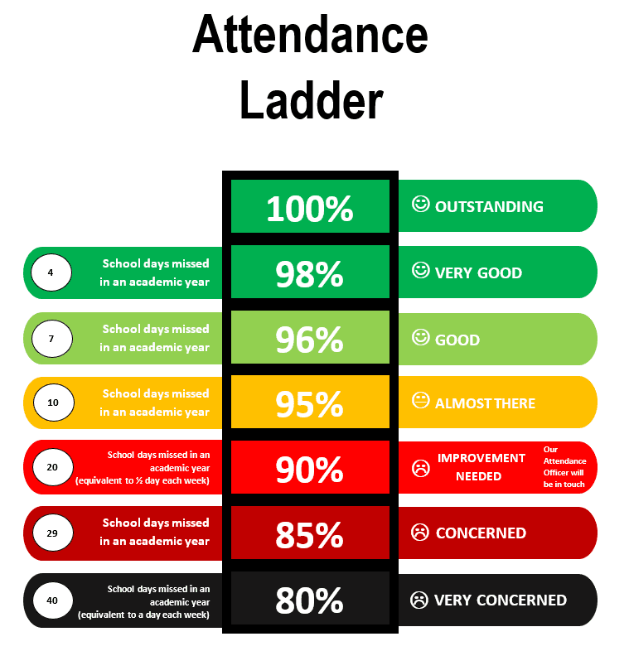
Attendance & Holidays

School attendance still is one of the biggest issues we as a school and the government are trying to tackle and improve. As we all know the more children are in school, the wider their learning and experiences are. Therefore, we would like to remind our parents that pupils need to be in school for 8:45am. If your child will be late in, absent or attending a medical appointment, you must contact the school office first thing to notify us. Please do NOT send messages via Class Dojo as teachers will not always see these until later in the day, and will result only in the office staff contacting you themselves.
Finally taking pupils out during term time for the purposes of a holiday is not appropriate and we would urge any families who currently have any booked to strongly consider moving these to coincide with school holidays. However, the school must be advised of all holidays in advance by the completion of the ‘Leave of Absence’ form which is available from the school office.
As you may well know by now, the school congratulates the classes who achieve 98% attendance in a week, by allowing all pupils in these classes to have a dress down day the following Friday. Details will be published each week on Class Dojo.

January
22nd January | Year 3 & Year 4 Viking Raiders Day
 | February
4th February | Residential Launch meeting – Year 4 & Year 5 - more details to follow
13th February | Pyjama Non-Uniform Day
13th February | Movie Night 3.15pm – 5pm
13th February | End of Half Term
23rd February | Pupils Return from Half term holiday
26th February | Rock Kidz Day – Non Uniform
 | March
5th March | World Book Day – Non Uniform
20th March | Red Nose Day
27th March | Bingo Night – Eyes Down 7.30pm
27th March | End of Term
April
14th April | Pupils return from Easter Holiday
22nd April | Year 5 & Year 6 – Planetarium Day
29th April | Year 6 Crucial Crew
 | May
1st May | May Day Madness – Break the Rules Day
3rd May | Mini Gear
Upcoming Events

