A Few Reminders
The first month of the academic year has flown by already and it’s wonderful to see so many of our new pupils settling in wonderfully into their new school.
After a period of settling in there are a few reminders we would like to
reiterate to parents to ensure a fluent and safe environment;
- Earrings – must be taken out for PE and Forest school sessions if able
to. Those unable to be removed will be covered with tape for safety
reasons. Can we also remind parents that only stud earrings are
permitted, hoops or dangly earrings are unacceptable.
- Playground Equipment – At the end of the day please can we ask parents to supervise their children and ensure they are not playing on the apparatus; our insurance does not cover any accidents by non Howard Junior pupils on this.
- Sickness – If your child is too unwell to attend school please can you make sure you call the office and leave a message. If you message via Dojo you may still be contacted as these messages are not always picked up by teachers until later in the morning.
Message from the Principal
Since the start of term, we have been using the Salford Reading Test to help us match
children’s reading books to their reading age and comprehension age. Each pupil has been
issued a reading book from the new library – along with their reading record – to bring
home and back to school daily. We are proud of the new library resource and hope these
changes help our pupils develop a lifelong love of reading.
Following our first Academy Committee meeting this term, we are now actively seeking
two parents to join our committee. The Academy Committee plays a vital role in
supporting the academy on its improvement journey and in holding the academy to
account. If this is a role that is of interest to you or you would like to find out more
about this opportunity, I would encourage you to register your interest by emailing us
at: office@hjs.eastern-mat.co.uk.
Opportunities is one of our school values and we are really proud of the children who have already taken up the opportunity to represent our school in both football and hockey competitions. We have more competitions coming up this month, including football, cross country and dodgeball.



Mr. Ben Paull
Upcoming Dates
for your
diary
Halloween Non Uniform & Disco
24th October 2025
Online Safety Info
15th October 2:10-3:10
Bikeability (Select Children)
15th & 16th Oct 2025

Last Day
24th October 2025
Supporting Your Child

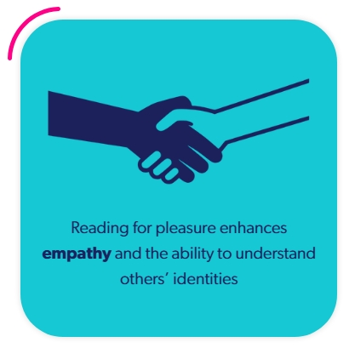
Supporting your child in their education is vitally important, not just as a school but also having the support from parents too. There are many ways that you as a parent/carer can support but the most valuable to us at the moment are;
- Reading and Homework support – Reading is the foundation for which an education is set upon. Reading regularly and for pleasure can foster the development of stronger reading habits and increase literacy skills at a greater rate than through formal literacy lessons. Just 10 minutes five times a week can have a huge impact on your child’s literacy skills, improving their confidence throughout their education. So, we would like your support in listening to your children to read or encouraging them to do free reading where possible along with completing the small amount of homework set to support their home learning.
- Attendance – Ensuring your child is in school and on time every day, will help them to access their education – missing a lesson is like missing out a chapter of a book, the subject is harder to understand without the full story. So please support us and your child by encouraging regular attendance and a polite reminder that we can administer Calpol for minor ailments to help them through the day when a little under the weather.

Upcoming Events
October
10th October | Flu Immunisation (Follow up)
13th October | Cross Country Competition – Select Children
13th October | Open Evening for New Pupils
15th October | Adult Learning Zone – Safeguarding Children & Technology 14:10-15:10pm
15th – 16th October | Bikeability Level 1 & 2 – Select Children
24th October | Halloween Disco
24th October | Halloween Non-Uniform Day
24th October | Last Day of Term
November
3rd November | Pupils Return to School
4th November | Adult Learning Zone – Place Value 13:15 - 15:15
11th November | Adult Learning Zone – Fractions & Decimals 13:15 – 15:15
18th – 26th November | Travelling Book Fair
18th November | Adult Leaning Zone – Measurement 13:15 – 15:15
18th November | Parents Evening – 15:30 – 18:00
19th November | Parents Evening – 15:30 – 18:00
21st November | Bingo Night
25th November | Adult Learning Zone – Geometry (Shapes) 13:15 – 15:15
December
10th December | Whole School Pantomime Trip
11th December | Christmas Church Service – Whole School

