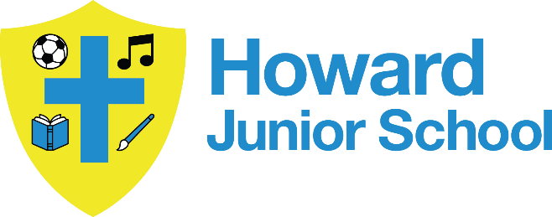


Howard Junior School Young Carers Policy

Principal  B Paull | Sign and Date | 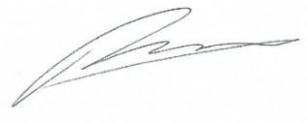  07.07.25

Next Review Date | 07.07.26
Committee Responsible | Governing Board – approved 07.07.25

Change History

Version | Date | Change Description | Stored
1
2
3
4
5
6

Howard Junior School Young Carer Policy
Howard Junior School is committed to supporting young carers to access education. This policy aims to ensure young carers at Howard Junior School are identified and offered appropriate support to access the education to which they are entitled.
Definition
A young carer is a child or young person (under 18 years old) who is helping to look after someone. This may be at home, but could also be a person who lives away from the family home. Most are caring for a parent, but some may be taking responsibility for a sibling, grandparent or other relative. It may also be the case that the young carer is looking after a family friend.
In some instances, a young carer may care for more than one person.
The person(s) they look after will have one or more of:
- Physical disability (including sensory disability)
- Learning disability
- Mental health problem
- Chronic illness
- Substance misuse problem
A young carer will take on additional responsibilities to those appropriate to their age and development. A young carer might be providing the main care or share responsibilities with another family member. The caring tasks that a young carer has to deal with can range from:
- Nursing care - giving medication, injections, changing dressings, assisting with mobility etc.
- Personal intimate care - washing, dressing, feeding and helping with toilet requirements.
- Emotional care - being compliant, monitoring the emotional state of the person cared for, listening, being a shoulder to cry on, supporting a parent through depression and trying to cheer them up.
- Domestic care - doing a substantial amount of housework, cooking, shopping, cleaning, laundry etc.
- Financial care - running the household, bill paying, benefit collection etc.
- Child care - taking responsibility for younger siblings in addition to their other caring responsibilities.
At Howard Junior School, we believe that all children and young people have the right to an education, regardless of what is happening at home.
When a young person looks after someone in their family who has a serious illness, disability or substance misuse problem, he or she may need a little extra support to help him or her get the most out of school. Our Young Carers Policy says how we will help any pupil who helps to look after someone at home.
Our school:
- Has a member of staff with special responsibility for young carers and lets all new pupils know who they are and what they can do to help.
- Can put young carers in touch with the local Young Carers Service. We can also put families in touch with other support services.
- Is accessible to parents who have mobility and communication difficulties and involves them in parents’ evenings.
- Respects your right to privacy and will only share information about you and your family with people who need to know to help you.
- Will consider alternatives if a young carer is unable to attend out of school activities e.g. detention, sports coaching, concerts, due to their caring role.
- Allows young carers to telephone home during breaks and lunchtimes.
- Complies with the Disability Discrimination Act by offering disabled parents support to get their children into school.
Further information and support can be obtained from contacting the school inclusion manager:
Sophie Hopkins Via the school office or by email
Sophie.hopkins@hjs.eastern-mat.co.uk

